**SPH3U 9.2 Waves at Media Boundaries**

1. **Standing waves**

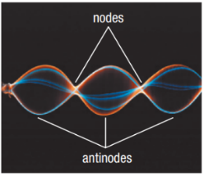

|  |  |
| --- | --- |
| Standing wave: |  |
| cause |  |
| nodes |  |
| antinodes |  |

1. **Standing waves – 2 fixed ends**

|  |  |
| --- | --- |
| Fixed end: |  |
| 2 fixed ends |  |

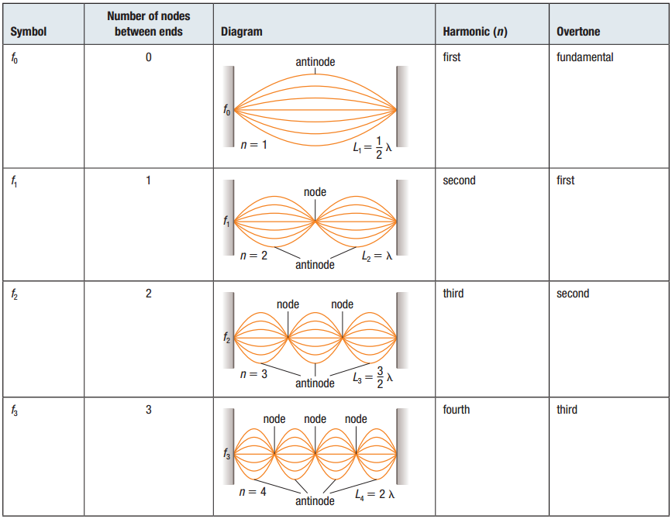

1. **Standing waves – 2 free ends**

|  |  |
| --- | --- |
| Free end: |  |
| 2 free ends |  |

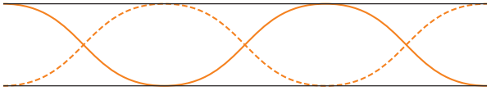

1. **Standing waves – fixed-free ends**

|  |  |
| --- | --- |
| Fixed-free ends: |  |

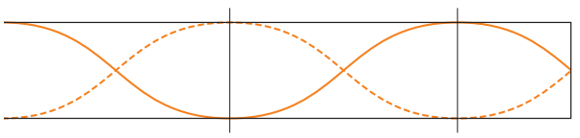

1. **Equations**

|  |  |
| --- | --- |
| 2 fixed or 2 free: |  |
| Fixed-free: |  |

The speed of a wave on a string with a fixed end and a free end is 350 m/s. The frequency of the wave is 200.0 Hz. What length of string is necessary to produce a standing wave with the first harmonic?

The sixth harmonic of a 65 cm guitar string is heard. If the speed of sound in the string is 206 m/s, what is the frequency of the standing wave?

**Homework:** page 426: #5-7